XDK Communication Equipment (HuiZhou) Co., Ltd. Internal Specification

**SC-SC0.9mmPMFiberJumper Specification**

V1.1

2019/10/9

https://exmail.qq.com/cgi-bin/viewfile?type=signature&picid=ZX1210-I7D7eopNecNIixBJBcrhZ7k&uin=2612719763

XDK Communication Equipment (HuiZhou) Co., Ltd.

All rights reserved

**Catalogue**

1 Outline Drawing 3

2 Type and spec 4

3 Performances of SC 0.9mm PM Fiber Connector (according to YD/T 2341.2-2011 ) 5

3.1 Insertion Loss 5

3.2 Return Loss 6

3.3 ExtinctionRatio……………………………………………………………………………………………………...……………6

3.4 Mechanical and environment performance 6

4 Connector requirements 8

4.1 Ferrule dimension 9

|  |  |  |
| --- | --- | --- |
| Workingtemperature range | | -25℃~70℃ |
| Working humidity | | 0%~95% |
| Transport temperature range | | -5℃~50℃ |
| Application | | FTTH |
| Service life | | ≥25 years |
| Reference standards | Optical fiber | ITU-T G.657, ITU-T G.652 |
| Connector | YD/T 2341.2-2011,YD/T 1272.3-2005, IEC 61753-1 category C, IEC 61754-4, Q/CT 2299-2010 |
| Remark | | Other requirements not mentioned should fulfill the reference standards above. |

# 1 Outline Drawing

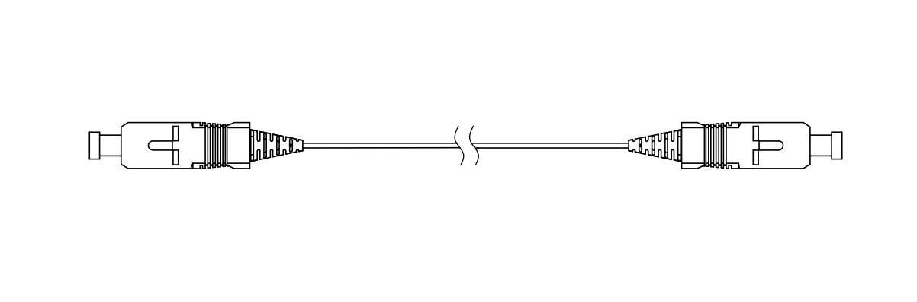

**SC 0.9mm PM Fiber Connector**

1. SC-Type Splice-On-Connector outline drawing

# 2 Type and spec

1. *List of SC-SOC of different types*

|  |  |  |  |  |  |  |
| --- | --- | --- | --- | --- | --- | --- |
| Item | Connector type | type | Mode | Fiber Type | Fiber Length | Boot type |
| 1 | SC | UPC | SM | 0.9mm PM fiber | L | 0.9 mm Boot |

# 3 Performances ofSC/UPC PM connector(according to YD/T 2341.2-2011 )

## 3.1 Insertion Loss

Test method: IEC61300-3-4 (insertion method B))

Test wavelength: 1310 nm and 1550 nm

Insertion loss: see table 2.

1. *Insertion loss and return loss*

|  |  |  |
| --- | --- | --- |
| **Item** | | **Single Mode** |
| Insertion loss(Max) | UPC | 0.20 dB(maximum) |
| Return loss(Min) | UPC | ≥50dB |

## 3.2Return Loss

Test method: IEC61300-3-6 (OCWR method)

Test wavelength: 1310 nm and 1550 nm

Return loss: see table 2.

**3.3Extinction Ratio**

**The extinction ratio (ER)** is the ratio of the minimum transmitted light intensity to the maximum transmitted light intensity of the polarizer relative to the detected polarizer, referred to as ER. This parameter is mainly used in digital pulsed light transmitters, and is defined as the ratio of the average optical power p1 when the transmitted laser power is all "1" and the average optical power p0 at all "0". Generally this parameter can be expressed in logarithmic form, such as EXT=10lg(p1/p0)(dB)

**EXT=10lg(P1/P0)(dB)**

By formulaER $≤{-10 log(tan}^{2}{θ}）$ ER≥20dB, angle difference is less than or equal to ±3°。

|  |  |  |
| --- | --- | --- |
| **Item** | | **Single Mode** |
| ER(Min) | UPC | 20dB  Or 25dB |

## 3.4 Mechanical and environment performance

1. *Mechanical and environment performance*

|  |  |  |  |  |  |  |  |
| --- | --- | --- | --- | --- | --- | --- | --- |
| **Item** | **Test Method** | | | | **Requirements** | | |
| **△IL** | **ER** | **Appearance** |
| Thermal Age Test | Test method: GR326 4.4.2.1  Test wavelength: 1550nm  Test temperature: 85℃  Duration of exposure:168H  Sampling rate(IL and RL、ER): initially and after test | | | | ≤0.2dB | ≥20dB | There shall be no damage to the connector under visual inspection. |
| Thermal Cycle Test | Test method: IEC61300-2-22.  Test wavelength: 1550 nm  Temperature: -25℃~70℃  Duration of extreme temperatures: 1h  Temperature rate of change: 1℃/min  Number of cycles: 12  Sampling rate(IL and RL、ER): initially at room ambient, after 0.5 h during each dwell (measurements to be completed during dwell) and at the end of the test at room ambient. | | | | ≤0.2dB | ≥20dB | There shall be no damage to the connector under visual inspection. |
| Humidity Aging Test | Test method: GR326 4.4.2.3  Test wavelength: 1550nm  Test temperature: 75℃ 95%RH  Duration of exposure:168H  Sampling rate(IL and RL): initially and after test | | | | ≤0.2dB | ≥20dB | There shall be no damage to the connector under visual inspection. |
| Cold | Test method: IEC61300-2-17  Test wavelength: 1550 nm  Temperature: -40℃  Duration of exposure: 96h  Sampling rate(IL and RL): initially and after test | | | | ≤0.2dB | ≥20dB | There shall be no damage to the connector under visual inspection. |
| Vibration (sinusoidal) | Test method: IEC61300-2-1  Test wavelength: 1550 nm  Frequency range: 10 Hz to 55 Hz  Change in frequency: 1 oct /min  Number of axes: three orthogonal  Number of sweeps (10-55-10 Hz) per axis: 15  Vibration amplitude: 0.75 mm  Sampling rate (IL and RL、ER): initially and after each axis.  Measurement interval during the test shall be < 2 ms and transient monitoring shall be performed according to IEC 61300-3-28. | | | | ≤0.2dB | ≥20dB | There shall be no damage to the connector under visual inspection. |
| Impact | Test method: IEC61300-2-12, method A  Test wavelength: 1550 nm  Drop height: 1.5m  Number of drops: 8 for each plug  Sampling rate(IL and RL、ER): initially and after the last drop. | | | | ≤0.2dB | ≥20dB | There shall be no damage to the connector under visual inspection. |
| Mating durability | Test method: IEC61300-2-2  Test wavelength: 1550 nm  Coupling mechanism to be cycled: plug-adaptor  Cycling rate: not less than 3 s between each engagement and separation  Number of cycles: 500 minimum  Sampling rate(IL and RL、ER): measurements are recorded after each 10 times mating. | | | | ≤0.2dB | ≥20dB | There shall be no damage to the connector under visual inspection. And the interface shall be no visible scratch. |
| Straight pull | Test method: IEC61300-2-6  Test wavelength: 1550 nm  Load:  7 N / 900 μm Fiber  Rate of application: 50 N/min ~ 250 N/min  Duration: 120 s  Sampling rate(IL and RL、ER): initially and after the load. | | | | ≤0.2dB | ≥20dB | There shall be no damage to the connector under visual inspection. |
| Torsion | Test method: IEC61300-2-5  Test wavelength: 1550 nm  Tensile load:20 N at a speed of 1 N/s  Point of application of tensile load: 22 cm ~ 28 cm from the end face of the connector  Duration of the test: 25 cycles, ± 180°  Sampling rate (IL and RL、ER): at least once afterthe load has reached maximum level.  Note: Just for 2.0/3.0 mm cable | | | | ≤0.2dB | ≥20dB | There shall be no damage to the connector under visual inspection. |
| Transmission  with applied  tensile load | 0.9 mm  Soft Boot | Load | Angle | Time | ≤0.2dB | ≥20dB | There shall be no damage to the connector under visual inspection. |
| 0.2N | 90° | 120 Sec |

Remark :1. After each test, a visual inspection is carried out in the end;

2. During the test means the Max. interval time at 10min;

# 4 Connector requirements

## 4.1Ferrule dimension

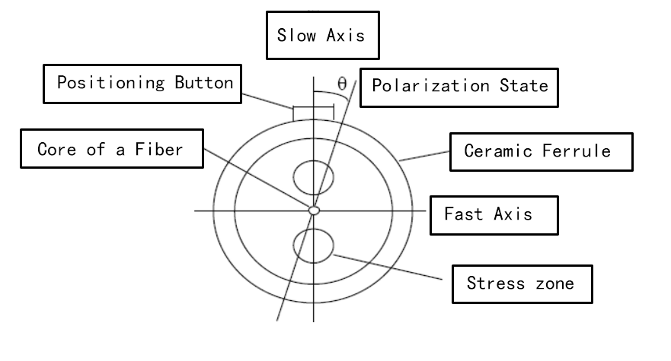

*Figure 2 Polarization adjustment diagram*

1. *Ferrule dimension*

|  |  |
| --- | --- |
| **Item** | **SC/UPC** |
| Fiber height | -125nm~50 nm |
| Radius of curvature | 7mm~25mm |
| Apex offset | 0~50μm |
| Ferrule diameter | 2.4985mm~2.4995mm |
| Polarization angle | ±3° |

## Ferrule Endface



*Figure 3 Ferrule Endface Partition Map*

1. *Ferrule EndfaceRequirements*

|  |  |  |  |
| --- | --- | --- | --- |
| Zone  ≤0.2 | Requirements | | |
| Debris  (maximum number  of a given dimension) | Defects  (maximum number  of a given dimension) | Scratches |
| A:core  0 μm to 25 μm | ≤1μm | ≤1μm | width < 1μm |
| B: cladding  25 μm to 120 μm | ≤1μm | ≤1μm | No limit < 1μm  3 from 1μm to 5μm  None > 5μm |
| C: adhesive  120μm to 130 μm | No loose dust | No limit | No limit |
| D: contact  135 μm to 250 μm | No loose dust | No limit | No limit |

Note:

1. Defects refer to chips, pits and contaminations.
2. For scratches, the requirement refers to width. For pits it refers to the maximum diameter
3. All loose particles must be removed by cleaning. Non-removable loose particles must

be within the criteria above to be acceptable for use.

1. There must no crack in the area of 0 to 120 μm;
2. The endface requirementsabove is referenced to the standard IEC61300-3-35